Kubernetes Task-05
Kubernetes Namespace, ResourceQuota & LimitRange Labs
Lab Overview
Task | Topic | Namespace
1 | ResourceQuota | dev-environment
2 | Pod requests & limits | prod-environment
3 | LimitRange | staging-environment
4 | Service DNS communication | default + test
5 | LimitRange memory ratio | performance-environment

Task 1 — Namespace + ResourceQuota
Requirement
Create namespace:
dev-environment
Quota:
Maximum Pods = 3
Maximum Services = 2
Step 1: Create namespace
kubectl create namespace dev-environment
Verify:
kubectl get namespaces
You should see:
dev-environment

Step 2: Create ResourceQuota YAML
Create:
vi dev-resource-quota.yaml
Add:
apiVersion: v1
kind: ResourceQuota
metadata:
name: dev-quota
namespace: dev-environment
spec:
hard:
pods: "3"
services: "2"
Save:
Esc
:wq
Enter

Step 3: Apply the quota
kubectl apply -f dev-resource-quota.yaml
Expected:
resourcequota/dev-quota created
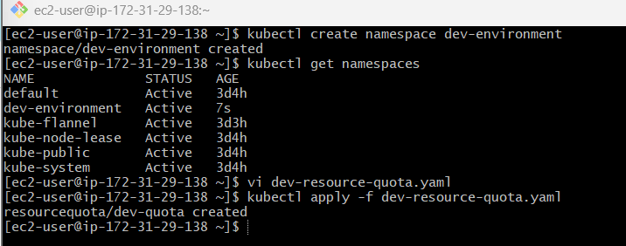

Step 4: Verify
kubectl get resourcequota -n dev-environment
More detailed:
kubectl describe resourcequota dev-quota -n dev-environment
You should see something similar to:
Resource Used Hard
-------- ---- ----
pods 0 3
services 0 2
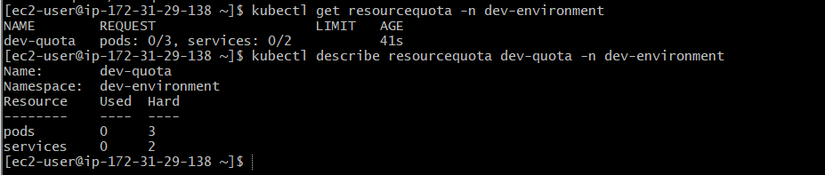
Important interview point
ResourceQuota controls the total amount of resources consumed by objects inside a namespace.
For this task:
dev-environment
|
+---- maximum 3 Pods
|
+---- maximum 2 Services

Task 2 — Pod Resource Requests and Limits
Requirement
Create a pod in:
prod-environment
Resources:
Resource | Request | Limit
CPU | 0.2 CPU | 0.5 CPU
Memory | 200Mi | 500Mi

Step 1: Create namespace
kubectl create namespace prod-environment
Verify:
kubectl get ns
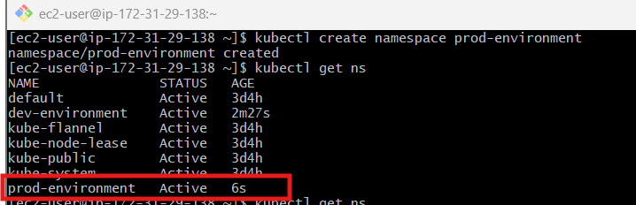

Step 2: Create Pod YAML
vi prod-pod.yaml
Add:
apiVersion: v1
kind: Pod
metadata:
name: prod-nginx
namespace: prod-environment
spec:
containers:
- name: nginx
image: nginx
resources:
requests:
cpu: "200m"
memory: "200Mi"
limits:
cpu: "500m"
memory: "500Mi"
Save:
Esc
:wq
Enter

Step 3: Apply
kubectl apply -f prod-pod.yaml
Expected:
pod/prod-nginx created

Step 4: Verify pod
kubectl get pods -n prod-environment
Expected:
NAME READY STATUS RESTARTS AGE
prod-nginx 1/1 Running 0 ...
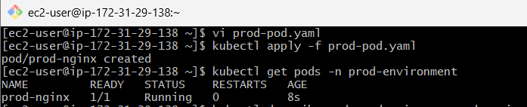

Step 5: Check resource configuration
kubectl describe pod prod-nginx -n prod-environment
Look for:
Requests:
cpu: 200m
memory: 200Mi

Limits:
cpu: 500m
memory: 500Mi
Understand this
CPU Request = 200m
CPU Limit = 500m

Memory Request = 200Mi
Memory Limit = 500Mi
200m means:
200 millicores = 0.2 CPU
500m means:
500 millicores = 0.5 CPU
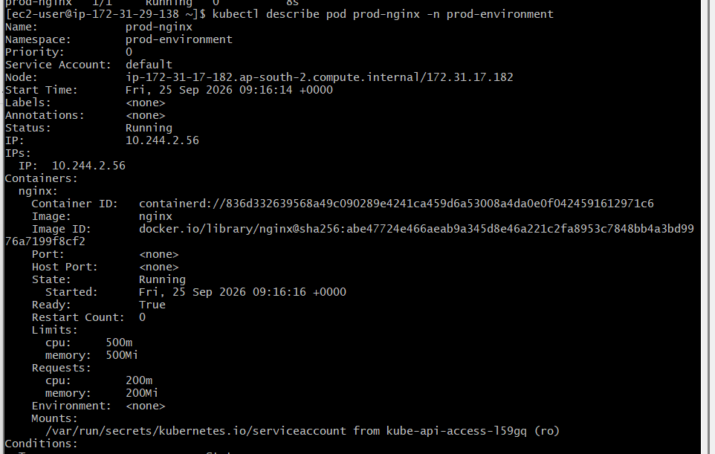

Task 3 — LimitRange in Staging
Requirement
Namespace:
staging-environment
Default:
CPU = 300m
Memory = 600Mi
Also apply:
Minimum CPU
Maximum CPU
We'll use:
Minimum CPU = 100m
Maximum CPU = 1 CPU
This means containers cannot request/limit less than 100m or more than 1 CPU.

Step 1: Create namespace
kubectl create namespace staging-environment

Step 2: Create LimitRange
vi staging-limitrange.yaml
Add:
apiVersion: v1
kind: LimitRange
metadata:
name: staging-limits
namespace: staging-environment
spec:
limits:
- type: Container
default:
cpu: "300m"
memory: "600Mi"
defaultRequest:
cpu: "300m"
memory: "600Mi"
min:
cpu: "100m"
max:
cpu: "1"
Save:
Esc
:wq
Enter

Step 3: Apply
kubectl apply -f staging-limitrange.yaml
Expected:
limitrange/staging-limits created

Step 4: Verify
kubectl get limitrange -n staging-environment
Then:
kubectl describe limitrange staging-limits -n staging-environment
You should see:
Type Resource Min Max Default
Container cpu 100m 1 300m
Container memory ... 600Mi
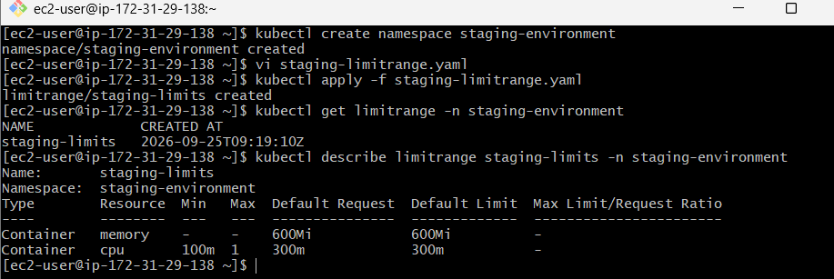

Step 5: Test the default values
Create a pod without specifying resources.
vi staging-pod.yaml
apiVersion: v1
kind: Pod
metadata:
name: staging-nginx
namespace: staging-environment
spec:
containers:
- name: nginx
image: nginx
Apply:
kubectl apply -f staging-pod.yaml
Now:
kubectl describe pod staging-nginx -n staging-environment
You should see Kubernetes automatically assigned:
Requests:
cpu: 300m
memory: 600Mi

Limits:
cpu: 300m
memory: 600Mi
Key concept
LimitRange works at the individual container/pod level.
ResourceQuota works at the namespace aggregate level.
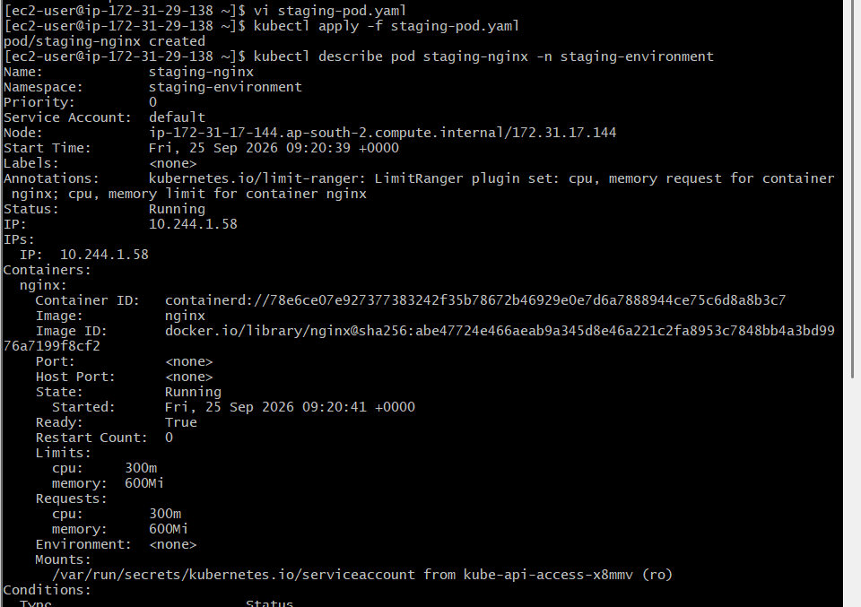

Task 4 — Service DNS Communication
This task is very important for Kubernetes interviews.
We will create:
default namespace
|
+--- nginx Pod
|
+--- NodePort Service
^
|
| DNS
|
test namespace
|
+--- test Pod

Part A — Create Nginx Pod
Create:
vi nginx-dns-pod.yaml
apiVersion: v1
kind: Pod
metadata:
name: nginx-dns
labels:
app: nginx-dns
spec:
containers:
- name: nginx
image: nginx
ports:
- containerPort: 80
Apply:
kubectl apply -f nginx-dns-pod.yaml
Verify:
kubectl get pods
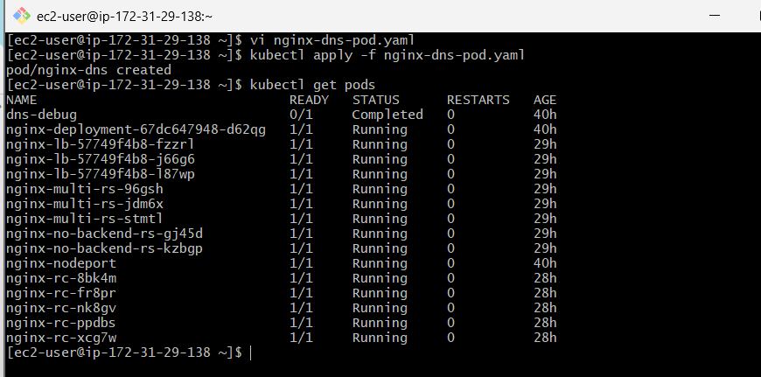

Part B — Create NodePort Service
Create:
vi nginx-nodeport.yaml
apiVersion: v1
kind: Service
metadata:
name: nginx-nodeport
spec:
type: NodePort
selector:
app: nginx-dns
ports:
- port: 80
targetPort: 80
nodePort: 30080
Apply:
kubectl apply -f nginx-nodeport.yaml
Verify:
kubectl get svc
You should see something similar to:
NAME TYPE CLUSTER-IP EXTERNAL-IP PORT(S)
nginx-nodeport NodePort 10.x.x.x <none> 80:30080/TCP
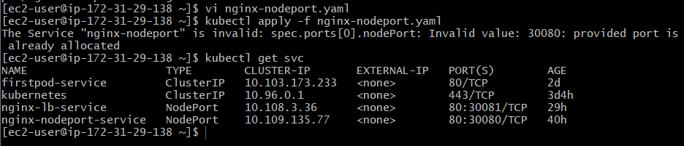

Part C — Verify Service Endpoints
Run:
kubectl get endpoints nginx-nodeport
You should see the nginx pod IP.
For newer Kubernetes versions, you can also use:
kubectl get endpointslice
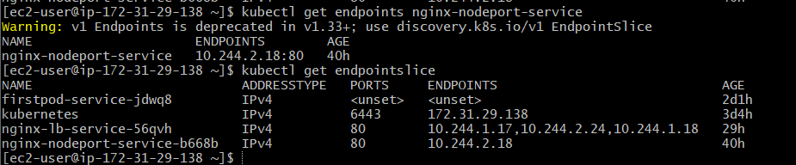

Part D — Create Test Namespace
kubectl create namespace test
Verify:
kubectl get ns
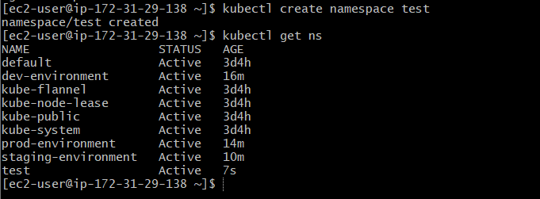

Part E — Create Test Pod
We'll use an Ubuntu container so that we can run network commands.
Create:
vi test-pod.yaml
apiVersion: v1
kind: Pod
metadata:
name: test-client
namespace: test
spec:
containers:
- name: ubuntu
image: ubuntu
command:
- sleep
- "3600"
Apply:
kubectl apply -f test-pod.yaml
Verify:
kubectl get pods -n test
Wait until:
test-client 1/1 Running
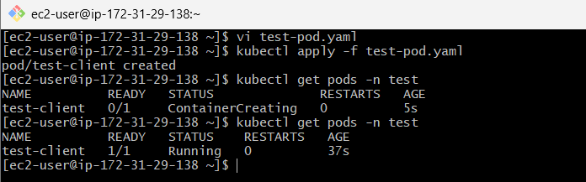

Part F — Test Service DNS
Enter the test pod:
kubectl exec -it test-client -n test -- bash
Inside the container, install curl:
apt update
apt install curl -y
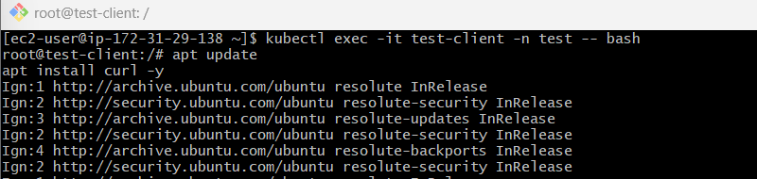
Now test:
curl http://nginx-nodeport.default.svc.cluster.local
You should receive the Nginx HTML response:
<!DOCTYPE html>
<html>
<head>
<title>Welcome to nginx!</title>
...
🎉 You have successfully communicated between namespaces using Kubernetes Service DNS.
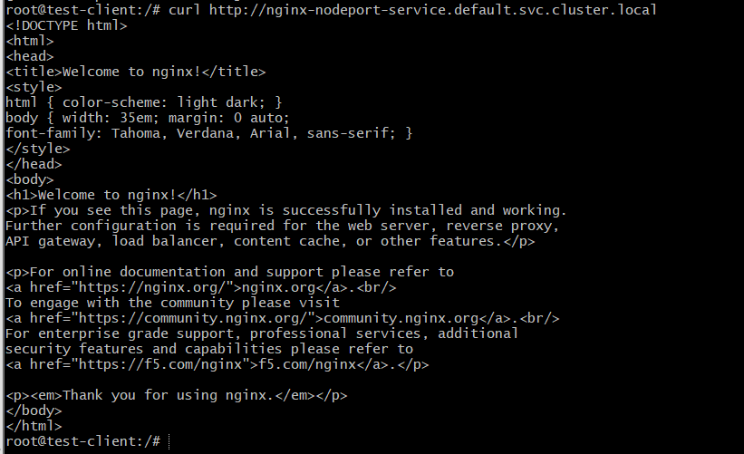

Understand the DNS Name
The full Kubernetes service DNS format is:
service-name.namespace.svc.cluster.local
Our service is:
nginx-nodeport
Namespace:
default
Therefore:
nginx-nodeport.default.svc.cluster.local
You can visualize it as:
test-client
|
| DNS lookup
|
v
nginx-nodeport.default.svc.cluster.local
|
v
nginx-nodeport Service
|
v
nginx-dns Pod
|
v
Nginx :80
Important
The NodePort is not required for pod-to-service communication inside the cluster.
For internal communication, use:
nginx-nodeport.default.svc.cluster.local
NodePort 30080 is primarily for exposing the service through a node IP.

Task 5 — Memory Request/Limit Ratio
Requirement
Create namespace:
performance-environment
Apply a LimitRange where:
maxLimitRequestRatio:
memory: 2
Then test a pod with mismatched memory request and limit.

Step 1: Create namespace
kubectl create namespace performance-environment

Step 2: Create LimitRange
vi performance-limitrange.yaml
Add:
apiVersion: v1
kind: LimitRange
metadata:
name: performance-limits
namespace: performance-environment
spec:
limits:
- type: Container
maxLimitRequestRatio:
memory: "2"
Save:
Esc
:wq
Enter

Step 3: Apply
kubectl apply -f performance-limitrange.yaml
Expected:
limitrange/performance-limits created
Verify:
kubectl describe limitrange performance-limits -n performance-environment
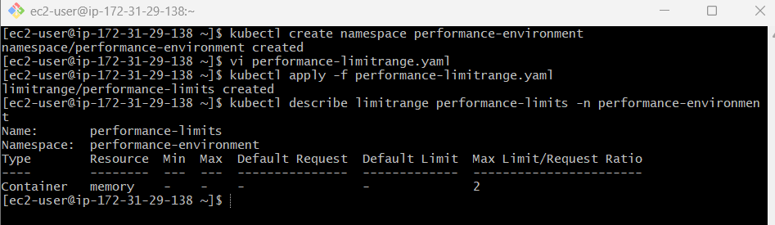

Step 4: Create a valid pod
The ratio must be:
Memory Limit / Memory Request <= 2
For example:
Request = 200Mi
Limit = 400Mi

400 / 200 = 2
Create:
vi performance-valid-pod.yaml
apiVersion: v1
kind: Pod
metadata:
name: performance-valid
namespace: performance-environment
spec:
containers:
- name: nginx
image: nginx
resources:
requests:
memory: "200Mi"
limits:
memory: "400Mi"
Apply:
kubectl apply -f performance-valid-pod.yaml
Expected:
pod/performance-valid created
Verify:
kubectl get pods -n performance-environment
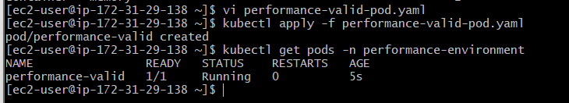

Step 5: Create an invalid pod
Now deliberately violate the ratio.
For example:
Request = 200Mi
Limit = 600Mi
Ratio:
600 / 200 = 3
But our maximum is:
2
Create:
vi performance-invalid-pod.yaml
apiVersion: v1
kind: Pod
metadata:
name: performance-invalid
namespace: performance-environment
spec:
containers:
- name: nginx
image: nginx
resources:
requests:
memory: "200Mi"
limits:
memory: "600Mi"
Apply:
kubectl apply -f performance-invalid-pod.yaml
You should receive an error similar to:
Error from server:
Invalid value: "2":
memory limit to memory request ratio
must not exceed 2
The exact wording can vary by Kubernetes version.
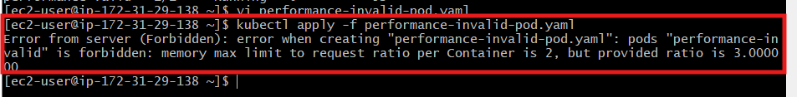

Why did it fail?
Kubernetes calculates:
Memory Limit
----------------
Memory Request
Our pod:
600Mi
------
200Mi
Result:
3
LimitRange allows:
Maximum ratio = 2
Therefore:
3 > 2
❌ Pod rejected.

